**JYOTHY INSTITUTE OF TECHNOLOGY**

INNOVATION AND DESIGN THINKING

ASSIGNMENT-01

NAME : KEERTHANA M J

BRANCH : CSE

SEM : 2nd SEM

SUBJECT CODE : BIDTK258

USN : 1JT23CS076

**Problem statement** :Traffic congestion in Urban area

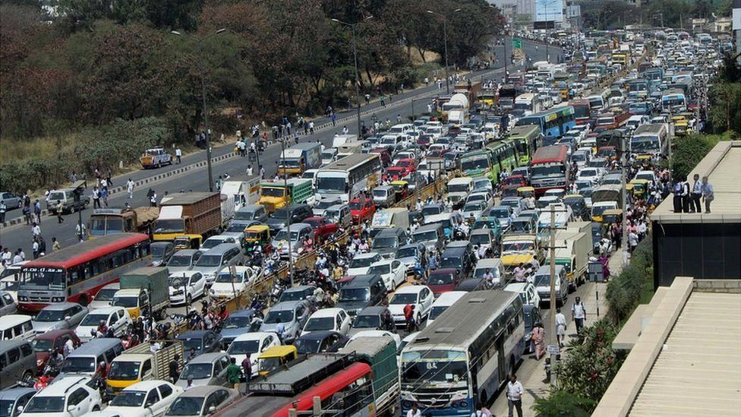

**INTRODUCTION:**

Traffic congestion occurs when the volume of traffic exceeds the available street capacity, resulting in slower speeds, longer trip times, and increased vehicular queueing

A good and effective transportation system accelerates the country's economic development and directly benefits for business, people, and the environment . However, large vehicles and increased transport activities on the road influence traffic congestion. Traffic congestion has been a major challenge in ensuring a sustainable transport system in most cities around the world.

Congestion increases travel costs and reduces accessibility by increasing travel times. Congestion exposure has substantial adverse effects, such as an increase in noise pollution, driver stress, decreased mental satisfaction, the city's economic growth, and increased passenger time pressure .

**EMPATHY:**

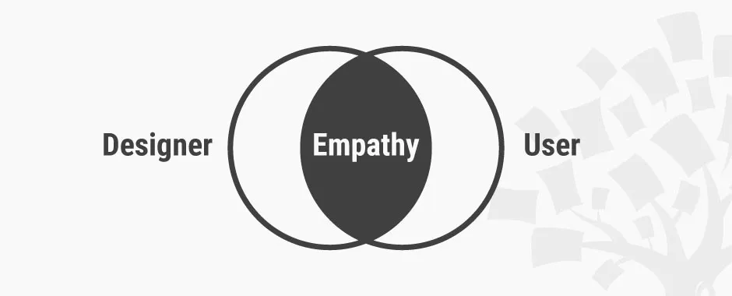

* Public transportation, cycling lanes, and pedestrian-friendly spaces can ease congestion. Carpooling and flexible work hours reduce the strain on roads.
* Urban planners, engineers, and policymakers must empathize with commuters to create sustainable, people-centric solutions.
* Solutions lie beyond wider roads and smarter algorithms. Empathy-driven design considers the human experience.
* Traffic congestion contribute to higher emmisions, leading to poor air quality and environmental degradation .
* Traffic jams result in lost productivity and increased transporatation costs.

**DEFINE:**

***TRAFFIC CONGESTION IN URBAN AREAS LIKE BENGALURU***

* Bengaluru was ranked the second most congested city in the world during 2022 in the city centre (BBMP area) category, according to the traffic index published by Dutch location technology specialist TomTom.

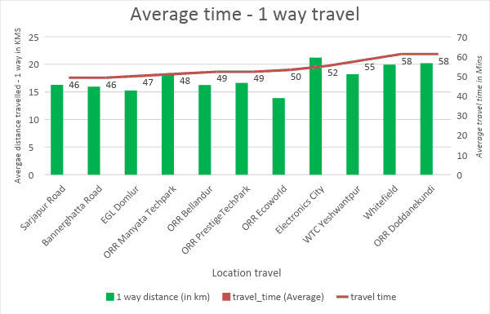

* On average, it took 29 minutes and 10 seconds for Bengalureans to cover 10km in the CBD area during 2022.
* The average speed during rush hour in the city centre was 18kmph against 14kmph in 2021.
* Bengaluru’s congestion levels came down to 48% in 2021 from 71% in 2019, which means a 32% decrease. The peak traffic congestion also reduced by 44% in 2021.
* The city saw its worst traffic day on October 9, 2021, when heavy rain caused certain waterlogged pockets resulting in widespread logjams and high congestion.
* Mumbai, New Delhi, and Pune saw an average decrease in congestion levels by 18%, 14%, and 29%, respectively. India fared better than the global average of 10% drop in congestion.

**Traffic congestion has a number of negative effects:**

* Wasting time of motorists and passengers ("opportunity cost"). As a non-productive activity for most people, congestion reduces regional economic health.
* Delays, which may result in late arrival for employment, meetings, and education, resulting in lost business, disciplinary action or other personal losses.
* Inability to forecast travel time accurately, leading to drivers allocating more time to travel "just in case", and less time on productive activities.
* Wasted fuel increasing air pollution and carbon dioxide emissions owing to increased idling, acceleration and braking.
* Wear and tear on vehicles as a result of idling in traffic and frequent acceleration and braking, leading to more frequent repairs and replacements.
* Stressed and frustrated motorists, encouraging road rage and reduced health of motorists
* Emergencies: blocked traffic may interfere with the passage of emergency vehicles traveling to their destinations where they are urgently needed.

Spillover effect from congested main arteries to secondary roads and side streets as alternative routes are attempted ('rat running'), which may affect neighborhood amenity and real estate prices.

Higher chance of collisions due to tight spacing and constant stopping-and-going.

**IDEATE:**

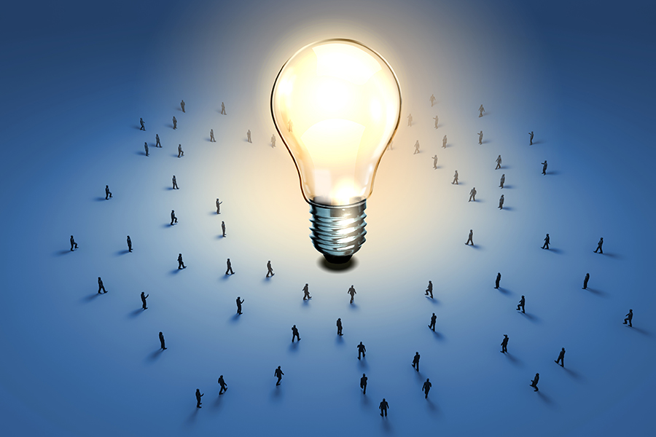

* **Revolutionize traffic light management**

One way to help reduce traffic congestion is to revolutionize the way that traffic lights are managed. By using data from sensors and GPS devices, traffic-light management systems can optimize traffic flow, reduce delays and help improve traffic flow.

* **Restrict parking near busy intersections**

Restricting parking near busy intersections is one way to help reduce traffic congestion. By reducing the number of cars on the road, you can also help to reduce pollution and save fuel.

* **Encourage the use of alternative routes**

The resulting delays can be frustrating for motorists and costly for businesses. However, there are steps that cities can take to reduce traffic congestion. One effective measure is to encourage the use of alternate routes.

* **Promote carpooling and ride-sharing**

Carpooling and ride-sharing are two more sustainable transportation options that can help to reduce traffic congestion. Carpooling is when two or more people share a ride in a single vehicle. This can be done by friends, family, or co-workers who are going to the same general area.

* **Build a robust light rail network**

A light rail network is another mass transit option that can help to reduce traffic congestion. Light rail is a type of train that runs on a dedicated track, often with its own right-of-way separate from other vehicles.

This can make light rail a faster and more efficient option than buses, which can get caught in traffic just like cars.

**PROTOTYPE:**

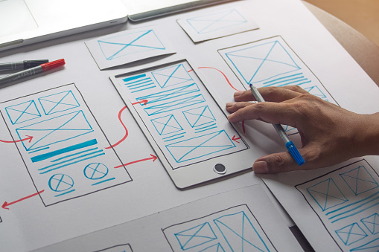

* A microcontroller such as an Arduino or Raspberry Pi is used to control LEDs representing traffic lights and sensors detecting vehicle presence. The system’s layout is designed to model intersections and traffic flow accurately.
* Traffic simulation software like SUMO can be utilized for detailed modeling and visualization of various traffic scenarios. By implementing control logic that adjusts traffic light timings based on vehicle detection, the prototype aims to optimize traffic flow and reduce congestion.
* Initial tests and refinements are conducted to ensure the system responds correctly to changing traffic conditions. Finally, performance metrics such as average wait time and queue lengths are analyzed to identify bottlenecks and further optimize the traffic management strategy.

**TEST:**

* **Run initial tests:** Test the prototype with simple scenarios to ensure basic functionallity of traffic light changes in response to vehicle detection
* **Simulate congestion scenarios:** Introduce congestion scenarios by increasing the number of detected vehicles and observing the system’s response
* **Refine System :**  Adjust traffic light timings and sensor sensitivity based on test results to improve traffic flowe and reduce congestion

**THANK YOU**